**Workshop – Black Box Testing**

**Question1: Boundary Value Analysis**

Assume, we have to test a field which accepts Age 18 – 56



**How many test cases should be checked here?**

**Your answer:**

|  |  |
| --- | --- |
| ***Test Scenario Description*** | ***Expected Result*** |
| **1. Boundary Value=17** | **System should not accept** |
| **2. Boundary Value=18** | **System should accept** |
| **3. Boundary Value=19** | **System should accept** |
| **4. Boundary Value=55** | **System should accept** |
| **5. Boundary Value=56** | **System should accept** |
| **6. Boundary Value=57** | **System should not accept** |

**Question 2: Equivalence partitioning**

In an Examination, a candidate has to score a minimum of 24 marks in order to clear the exam. The maximum that he can score is 40 marks.  Identify the Valid Equivalence values if the student clears the exam. Please draw also valid and invalid partitions.

a)    22,23,26  
b)    21,39,40  
c)    29,30,31  
d)    0,15,22

**Your answer:**

|  |  |
| --- | --- |
| ***Test Scenario Description*** | ***Expected Result*** |
| **1. 0-23 characters** | **System should not accept** |
| **2. 24-40 characters** | **System should accept** |
| **3. 41- and more characters** | **System should not accept** |

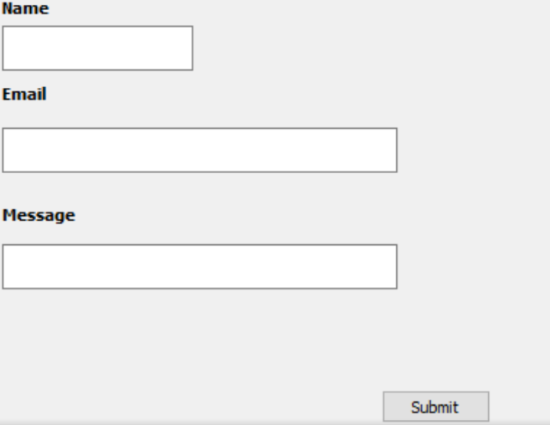**Question 3: Decision table**

**Submit button in Contact Form is**

**enabled when all the inputs are entered by the end user.**

**Your answer: Make decision table with T/F**

|  |  |  |  |  |  |  |  |  |
| --- | --- | --- | --- | --- | --- | --- | --- | --- |
|  | **Test Case1** | **Test Case2** | **Test Case3** | **Test Case4** | **Test Case5** | **Test Case6** | **Test Case7** | **Test Case8** |
| **Name** | **T** | **F** | **T** | **T** | **T** | **F** | **F** | **F** |
| **Email** | **T** | **T** | **F** | **T** | **F** | **T** | **F** | **F** |
| **Message** | **T** | **T** | **T** | **F** | **F** | **F** | **T** | **F** |
| **Submit** | **Successfully** | **Error about the incorrect name** | **Error about the incorrect Email** | **Error about the incorrect Message** | **Error about the incorrect Email and Message** | **Error about the incorrect Name and Message** | **Error about the incorrect Name and Email** | **Error** |

**Question 4: State Transition table**

Login page of an application which locks the user name after three wrong attempts of password.

**Your answers**

1. **Draw State Transition Diagram**

Incorrect pass Incorrect pass

II attempt

III attempt

I attempt

Start

True True True Incorrect pass

PAGE LOCKED

ACCESS GRANTED

1. **Make State Transition table**

|  |  |  |  |
| --- | --- | --- | --- |
| **State** | **Login** | **Correct Password** | **Incorrect Password** |
| S1 I attempt |  | S4 | S2 |
| S2 II attempt |  | S4 | S3 |
| S3 III attempt |  | S4 | S5 |
| S4 ACCESS GRANTED |  | - | - |
| S5 PAGE LOCKED |  | - | - |